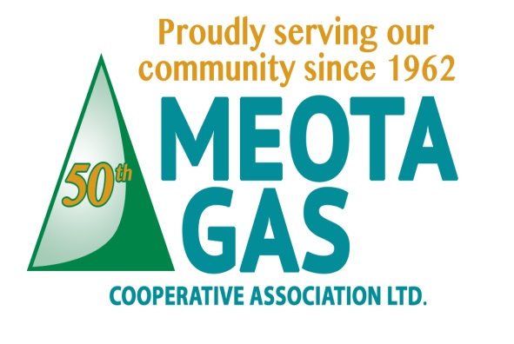
TEL: 403-931-2161
FAX: 403-931-2260
E-MAIL: admin@meotagas.com
178081 Priddis Valley Road W
Priddis, Alberta T0L 1W1

UPDATE OF CONTACT INFORMATION
Please provide your updated contact information, which is required in case of an emergency:

Name on account :_________________________________________________ Account #: ____________
Mailing Address: ___________________________________________________________________
___________________________________________________________________
911 (Municipal) Address (if not the same as mailing address): _______________________________________
_______________________________________
Phone: ____________________ Cell: _____________________ Alternate: ______________________
Email: ________________________________________________________________________________
To become cost efficient, we will be sending out bills by email unless specified otherwise.
Gate Code (if applicable): ________________
This is strictly for our purposes, under no circumstances do we give out any gate codes or contact information to anyone.

Alternate Contact: The reason for requesting an alternate contact is that in case of a gas emergency
we may need to gain access to your property in order to relight appliances.
Alt Contact Name: _____________________________ Alt Contact Phone: ____________________

If rental, Renter’s Name: __________________________________________________________
Address: _______________________________________________________________________
Phone: _____________ Cell: ____________ Email: ____________________________________

For up-to-date info, “LIKE: our page on Facebook: “MEOTA GAS CO-OP”
            

